J03. E.T.W. Dennis Series [1905]

Pu E.T.W. Dennis (Byatt 1978 : 85-86)
F Photograph printed in sepia half-tone with superimposed title; two different backs
J03A as below – includes printed greeting message
J03B as below
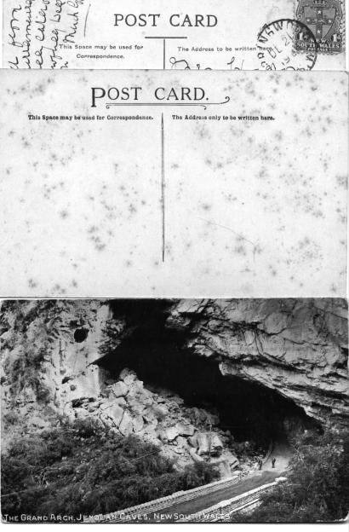

Most copies of these cards are trimmed so that only part of the E.T.W.D. imprint can be seen, but we have seen one with the complete initials, thus confirming this identification.

J3A
J03A.1 The Grand Arch, Jenolan Caves, New South Wales. H [pm.22 Dec.1905]

J03B.1 The Grand Arch, Jenolan Caves, New South Wales. H [pm.21 Dec.1906]
J03B.2 The Bathing Pool, Jenolan, N.S.W. V [pm.1 May 1908]
(note : sky is tinted blue)

